**Creating a Spring Home Controller and View – Overview**

**Creating a Spring Home Controller and View**:

Now we develop Spring controllers and views.

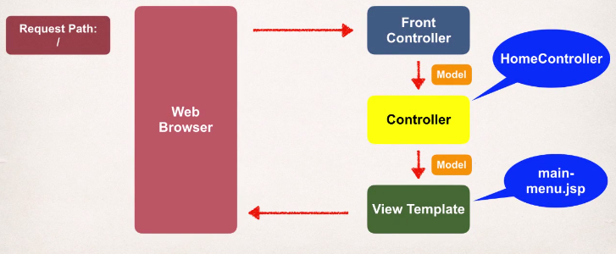

Here we actually set up a request mapping for a given path, and then we’ll have a controller that’s going to handle the request, then it’s going forward over to a view template which we’ll call **main-manu.jsp.**

**Development Process (Step by Step)**:

1. Create Controller class
2. Define Controller method
3. Add Request Mapping to Controller method
4. Return View Name
5. Develop View Page

**Step 1: Create Controller class**:

Define a class and annotate the class with @Controller annotation. @Controller basically say this is a Spring MVC controller and @Controller inherit from @Component.

@Controller

**public** **class** HomeController {

}

**Step 2: Define Controller method**:

@Controllerpublic class HomeController {

public String showPage(){

...  
}

}

**Step 3: Add Request Mapping to Controller method**:

@Controller

**public** **class** HomeController {

@RequestMapping("/")

**public** String showPage() {

**return** **null**;

}

}

**Step 4: Return View Name**:

@Controller

**public** **class** HomeController {

@RequestMapping("/")

**public** String showPage() {

**return** "main-manu";

}

}

**Step 5: Develop View Page**:

<!DOCTYPE html>

<html>

<body>

<h2>Spring MVC Demo Home Page</h2>

</body>

</html>

Creating a Spring Home Controller and View – Overview